**Human and Media Laboratory Project**

**COVID-19 Detection Using CNN**

**1. Introduction**

CNN is a type of DNN, inspired by the visual system of the human brain, and is most commonly used in the analysis of visual imagery. This project used CNN with extra layers to improve the COVID-19 X-ray image classification accuracy. In neural networks, the CNN structure is specially designed to process the two-dimensional image tasks although it can also be used in one- and three-dimensional data. The convolutional layer, considered a main layer of a CNN, performs the operation called “convolution” which gives CNN its name. Kernels in the convolutional layer are applied to the layer inputs. All the outputs of the convolutional layers are convolved as a feature map. In this study, the Rectified Linear Unit (ReLU) has been used in the activation function with a convolutional layer which is helpful to increase the nonlinearity in the input image, as the images are fundamentally nonlinear in nature.

**2. Method**

In the experiments of this study, a primary dataset containing 288 X-ray images has been used as a base dataset. Of 288 images, 144 X-ray images belonged to confirmed COVID-19 patients, and the other 144 images belonged to normal or people with other diseases like pneumonia. The dataset used is available on Kaggle.

The proposed CNN model used are including convolutional (Conv2D), max pooling layers, dropout layers, activation function layers, batch normalization layers, flatten layer, and fully connected layers

**3. Results**

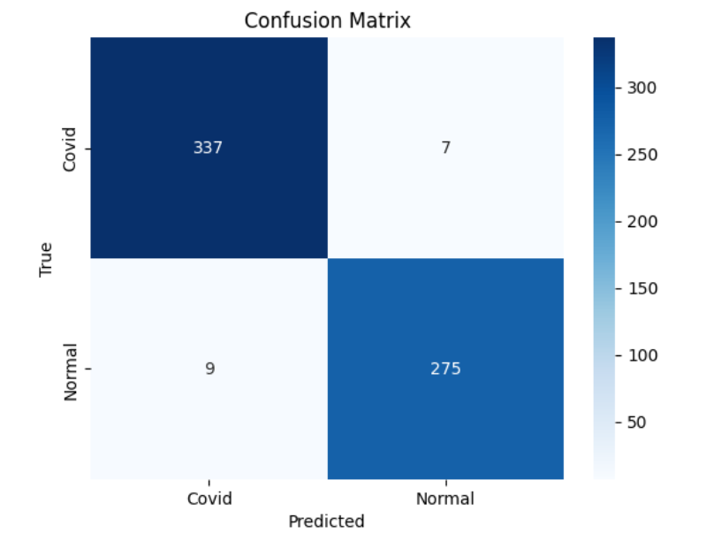

**Figure 3.1** Confusion Matrix of CNN model

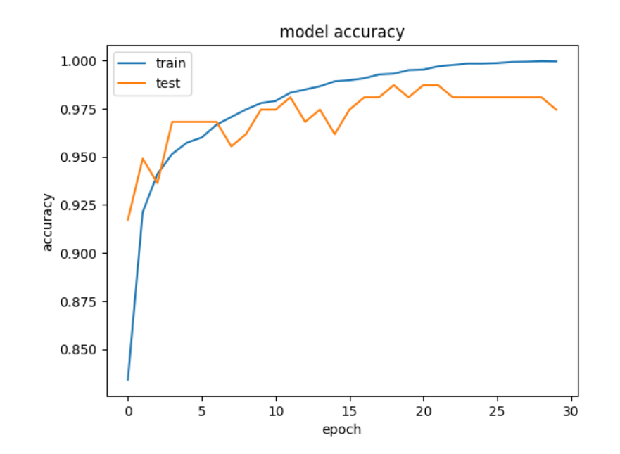

**Figure 3.2** Training and testing accuracy plot achieved by the CNN model

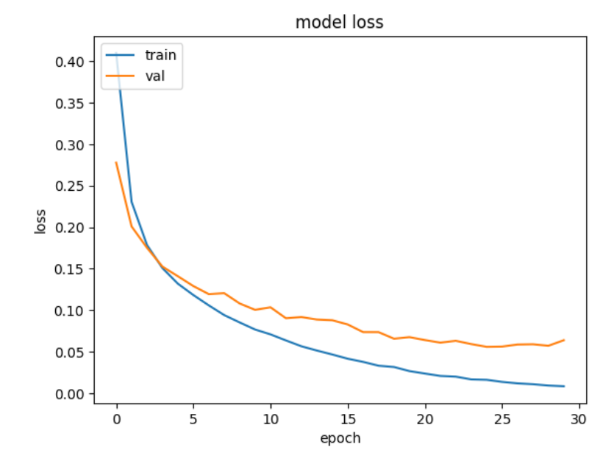

**Figure 3.3** Training and testing loss plot by the CNN

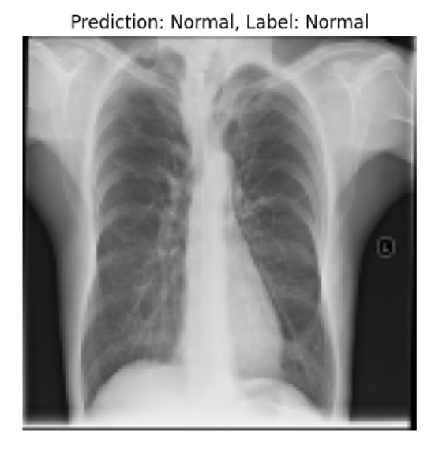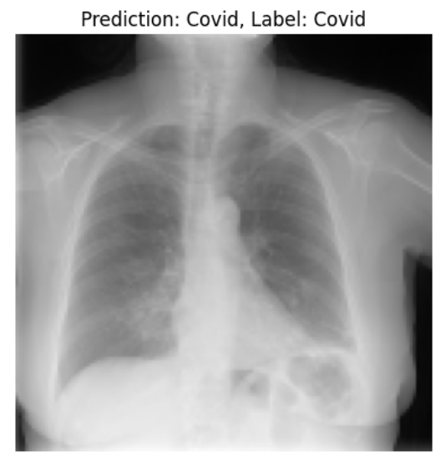

**Figure 3.4 The result of the COVID-19 detection**

**4. Discussion**

In medical imaging, besides detecting COVID-19 CNN is valuable in better accuracy in identifying tumors or other anomalies in X-ray and MRI images. Based on previously processed similar images by CNN networks, CNN models may analyze an image of a human body part, such as the lungs, and pinpoint where there might be a tumor and other anomalies like broken bones in X-ray images. Similarly, medical images like CT scans and mammograms can be used to diagnose cancer. In order to determine whether any indicators within a picture indicate malignancy or damage to cells owing to both hereditary and environmental factors, such as smoking habits, CNN models compare the image of a patient with database images that include comparable features.